**Question 1 (1 point)**

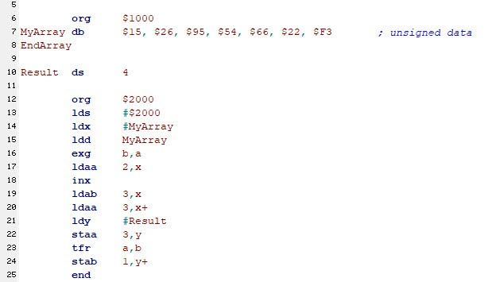  
  
   
Use the above code listing for the following questions.  
  
   
What HEX memory Address is associated with the label EndArray?

Question 1 options:

|  |  |
| --- | --- |
|  | $1005 |
|  | $1007 |
|  | $1006 |
|  | $1008 |

**Question 2 (1 point)**

What Addressing Mode is used in Line 15?

Question 2 options:

|  |  |
| --- | --- |
|  | INH |
|  | IDX |
|  | IMM |
|  | EXT |

**Question 3 (1 point)**

After the execution of exg b,a in line 16, B contains what HEX value?

Question 3 options:

|  |  |
| --- | --- |
|  | $10 |
|  | $15 |
|  | $26 |
|  | $62 |

**Question 4 (1 point)**

After the execution of ldaa 2,x in line 17, A contains what HEX value?

Question 4 options:

|  |  |
| --- | --- |
|  | $02 |
|  | $54 |
|  | $95 |
|  | $15 |

**Question 5 (1 point)**

What Addressing Mode is used for ldab 2,x in line 17?

Question 5 options:

|  |  |
| --- | --- |
|  | INH |
|  | CDX |
|  | IMM |
|  | IDX |

**Question 6 (1 point)**

What Addressing Mode is used for inx in line 18?

Question 6 options:

|  |  |
| --- | --- |
|  | IDX |
|  | INH |
|  | INX |
|  | IMM |

**Question 7 (1 point)**

After the execution of ldaa 3,x+ in line 20, what HEX value is in X?

Question 7 options:

|  |  |
| --- | --- |
|  | $1005 |
|  | $1007 |
|  | $1001 |
|  | $1004 |

**Question 8 (1 point)**

What HEX memory address is A stored in after the execution of staa 3,y in line 22?

Question 8 options:

|  |  |
| --- | --- |
|  | $1007 |
|  | $1011 |
|  | $100A |
|  | $1010 |

**Question 9 (1 point)**

After the execution of tfr a,b in line 23, what HEX value is in B?

Question 9 options:

|  |  |
| --- | --- |
|  | 66 |
|  | $66 |
|  | $26 |
|  | 26 |

**Question 10 (1 point)**

What HEX memory address is B stored in after the execution of stab 1,y+ in line 24?

Question 10 options:

|  |  |
| --- | --- |
|  | $1007 |
|  | $100A |
|  | $1008 |
|  | $1010 |

**Question 11 (2 points)**

Question 11 options:

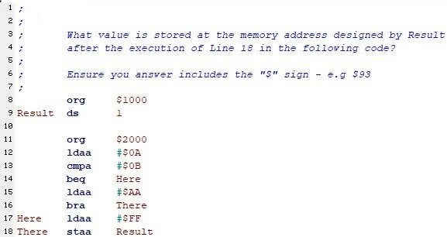

Answer: $AA

**Question 12 (2 points)**

Question 12 options:

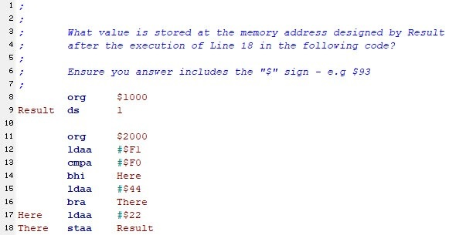  
  
   
Answer:



**Question 13 (2 points)**

Question 13 options:

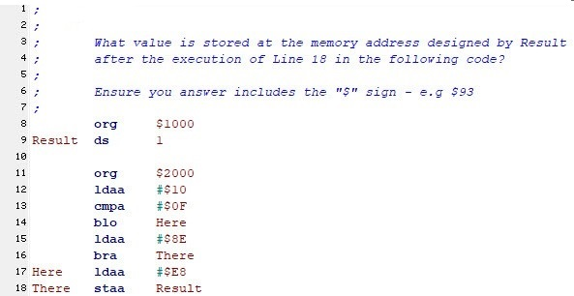  
  
   
Answer:



**Question 14 (2 points)**

Question 14 options:

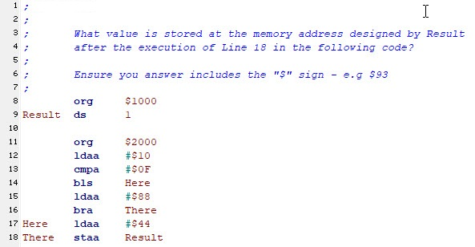  
  
   
Answer:



**Question 15 (2 points)**

Question 15 options:

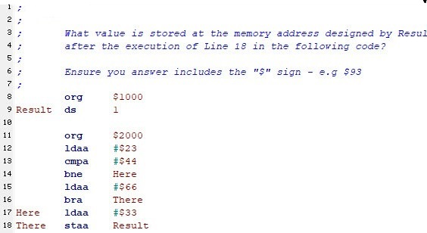  
  
   
Answer:

